Create a NodeJS and Deploy to Heroku

Adapted from:

[How to deploy a NodeJS app to Heroku from Github (without installing Heroku on your machine) (freecodecamp.org)](https://www.freecodecamp.org/news/how-to-deploy-a-nodejs-app-to-heroku-from-github-without-installing-heroku-on-your-machine-433bec770efe/)

# Step 1: Create package.json file

Create a new folder and open that folder in terminal

Open terminal and type: npm init

Keep hitting Enter to accept all default values

An example package.json could be like this

{

"name": "coolnodeapp",

"version": "1.0.0",

"description": "node app ",

"main": "app.js",

"scripts": {

**"start": "node app.js"**

},

"repository": {

"type": "git",

"url": ""

},

"author": "",

"license": "ISC",

"bugs": {

"url": ""

},

"homepage": ""

}

One very important change to notice is this line:

"start": "node app.js"

# Step 2. Add a file, app.js, and paste the below code

Notice: app.js and package.json in the same folder

const http = require('http');

const port = process.env.PORT || 3000

const server = http.createServer((req, res) => {

res.statusCode = 200;

res.setHeader('Content-Type', 'text/html');

res.end('<h1>Hello World</h1>');

});

server.listen(port,() => {

console.log(`Server running at port `+port);

});

You can test the app on local by typing at the terminal

node app.js

https://cdn-media-1.freecodecamp.org/images/e8L6vy5EQXp5av7XM0dnQ1UJ1ujUNKWg9x80

Open brownswer and run: <http://localhost:3000/>

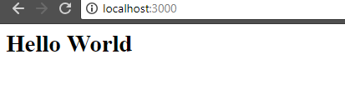

# STEP 3: Push to GitHub

Go to Github and create a new repository like this

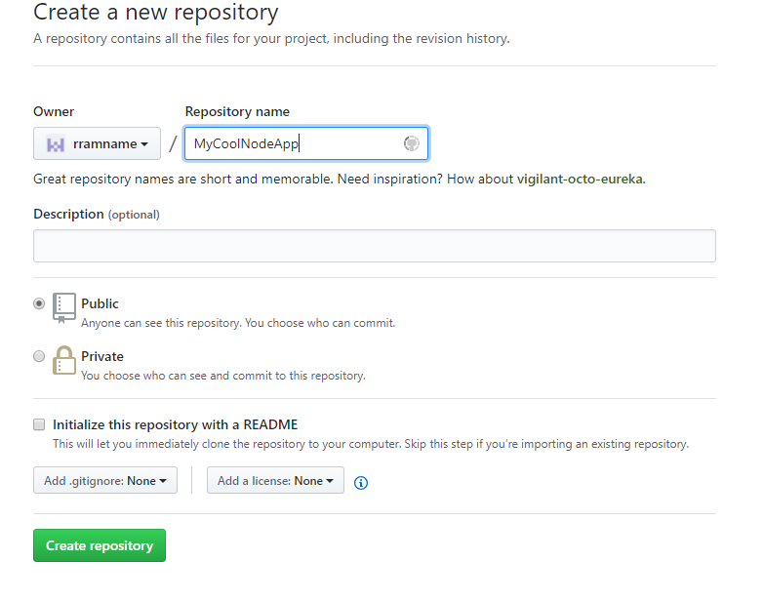

GitHub will create a repository and give you some commands that you can run locally so that you can clone your local folder with your GitHub repository.

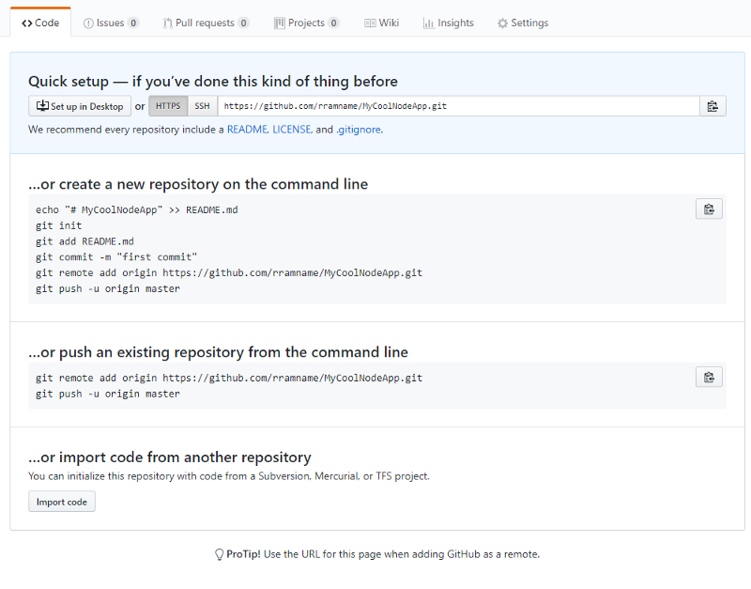

**In the same path with app.js** and type in the terminal

(Remember to replace your URL in remote address. Don’t use MyCoolNodeApp URI)

git init

git add .

git remote add origin https://github.com/rramname/MyCoolNodeApp.git

git push — set-upstream origin master

You should see messages like below at the command promp

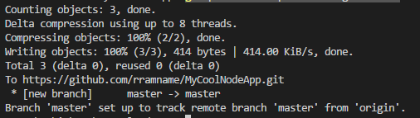

Now if you open GitHub and refresh the repository, you should be able to see the code.

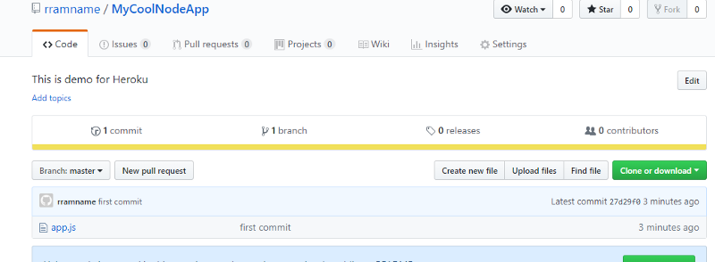

# Step 4 Deploy to Heroku

If you don’t have an account with Heroku, you can open a free one by filling out this [simple form](https://signup.heroku.com/login). (And here, you don’t need to provided Credit Card information :) )

### https://cdn-media-1.freecodecamp.org/images/375W2miDv-0ou4ZkP5Y3cyrrfapKcLksdBeY

Once you have your account ready, login with your credentials.

Click New on the top right corner and select “Create new app”.

Give your app a name (This will be included in the public URL for your application) and click Create app.

This step will take you to the dashboard of your app. Open Deploy tab and scroll to the “Deployment method” section.

Select GitHub as the method.

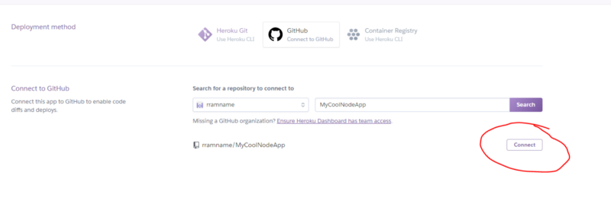

If it’s able to find and connect to the GitHub repository, the Deployment section will show up where you can select if you want Automatic Deployment (as soon as the changes are pushed to GitHub, Heroku will pick them up and deploy) or Manual Deployment.

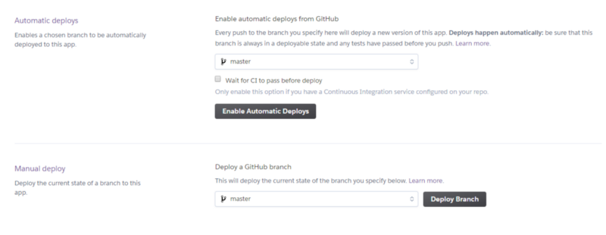

Click Enable Automatic Deploys (because it’s less overhead for demo apps :) ). You can also select the GitHub branch if you need to, but for this demo we will deploy from the master branch.

Now we need to tell Heroku that our app is a NodeJs app. For that, we will need the NodeJs build back.

Open the Settings tab and locate Buildpacks and click **“Add buildpack”.**

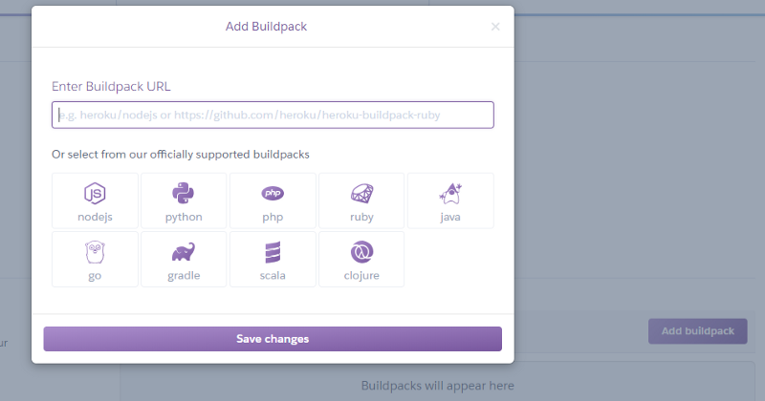

Select **nodejs**from the options and click Save changes.

Now, go back to the Deploy tab, and click **Deploy Branch** at the bottom.

Open the **settings** tab and scroll down to the **Domains and certificates**section. Here, you can see the URL of your app that was just deployed. Copy and paste that URL in the browser and… Hoooorah!!

